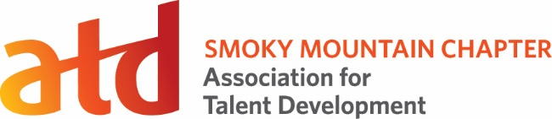

2020 Scholarship Application

Submission Deadline: Thursday December 31, 2020 at 12:00pm Noon

Instructions:
- Print or type information requested below.
- Provide a current resume showing education, professional experience, and achievements.
- Ask two (2) references that can support why you are a good candidate for the scholarship to complete the recommendation form.
- Submit application materials to students@atdsmokymountain.org

Personal Information:
Applicant Name:
Address:
City:
State:
Zip:
Phone:
Email:

Program of Study/ Interest: Provide details on the program you are interested in applying the scholarship towards.

Why: Describe why you chose this program and how it will make a difference for you as a talent development professional.

Yourself: Describe why you are a good candidate for the Smoky Mountain ATD Scholarship.

Signature: ______________________________ Date: __________________

Recipients will be required to speak to the chapter within 6 months after receipt of scholarship to provide an update on how the scholarship has assisted their talent development journey.

