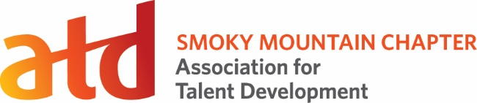

2022 Scholarship Recommendation
ATD Smoky Mountain Chapter established the ATD Smoky Mountain Scholarship Program to encourage and support professional development and continuing education in the field of talent development. Thank you in advance for providing a recommendation for below scholarship candidate.

Submission Deadline: December 31, 2022 12:00pm ET
Completed forms should be emailed to students@atdsmokymountain.org
Scholarship Candidate’s Name:
Scholarship Candidate’s Study Program:
Recommended By Name:
Title:
Organization:
Describe your relationship to the scholarship candidate:

Comments on the candidate’s qualities/credentials:
Achievements/Successes

Experience/Skills

Professionalism

Learning Attitude

Describe how the study program will be helpful to the candidate’s future aspirations, as related to the field of talent development:

Additional comments in support of the candidate’s application for an ATD Smoky Mountain Chapter Scholarship:

Signature: Date: _

